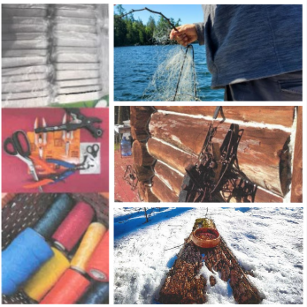

Canada Ontario Resource Development Agreement

(CORDA)
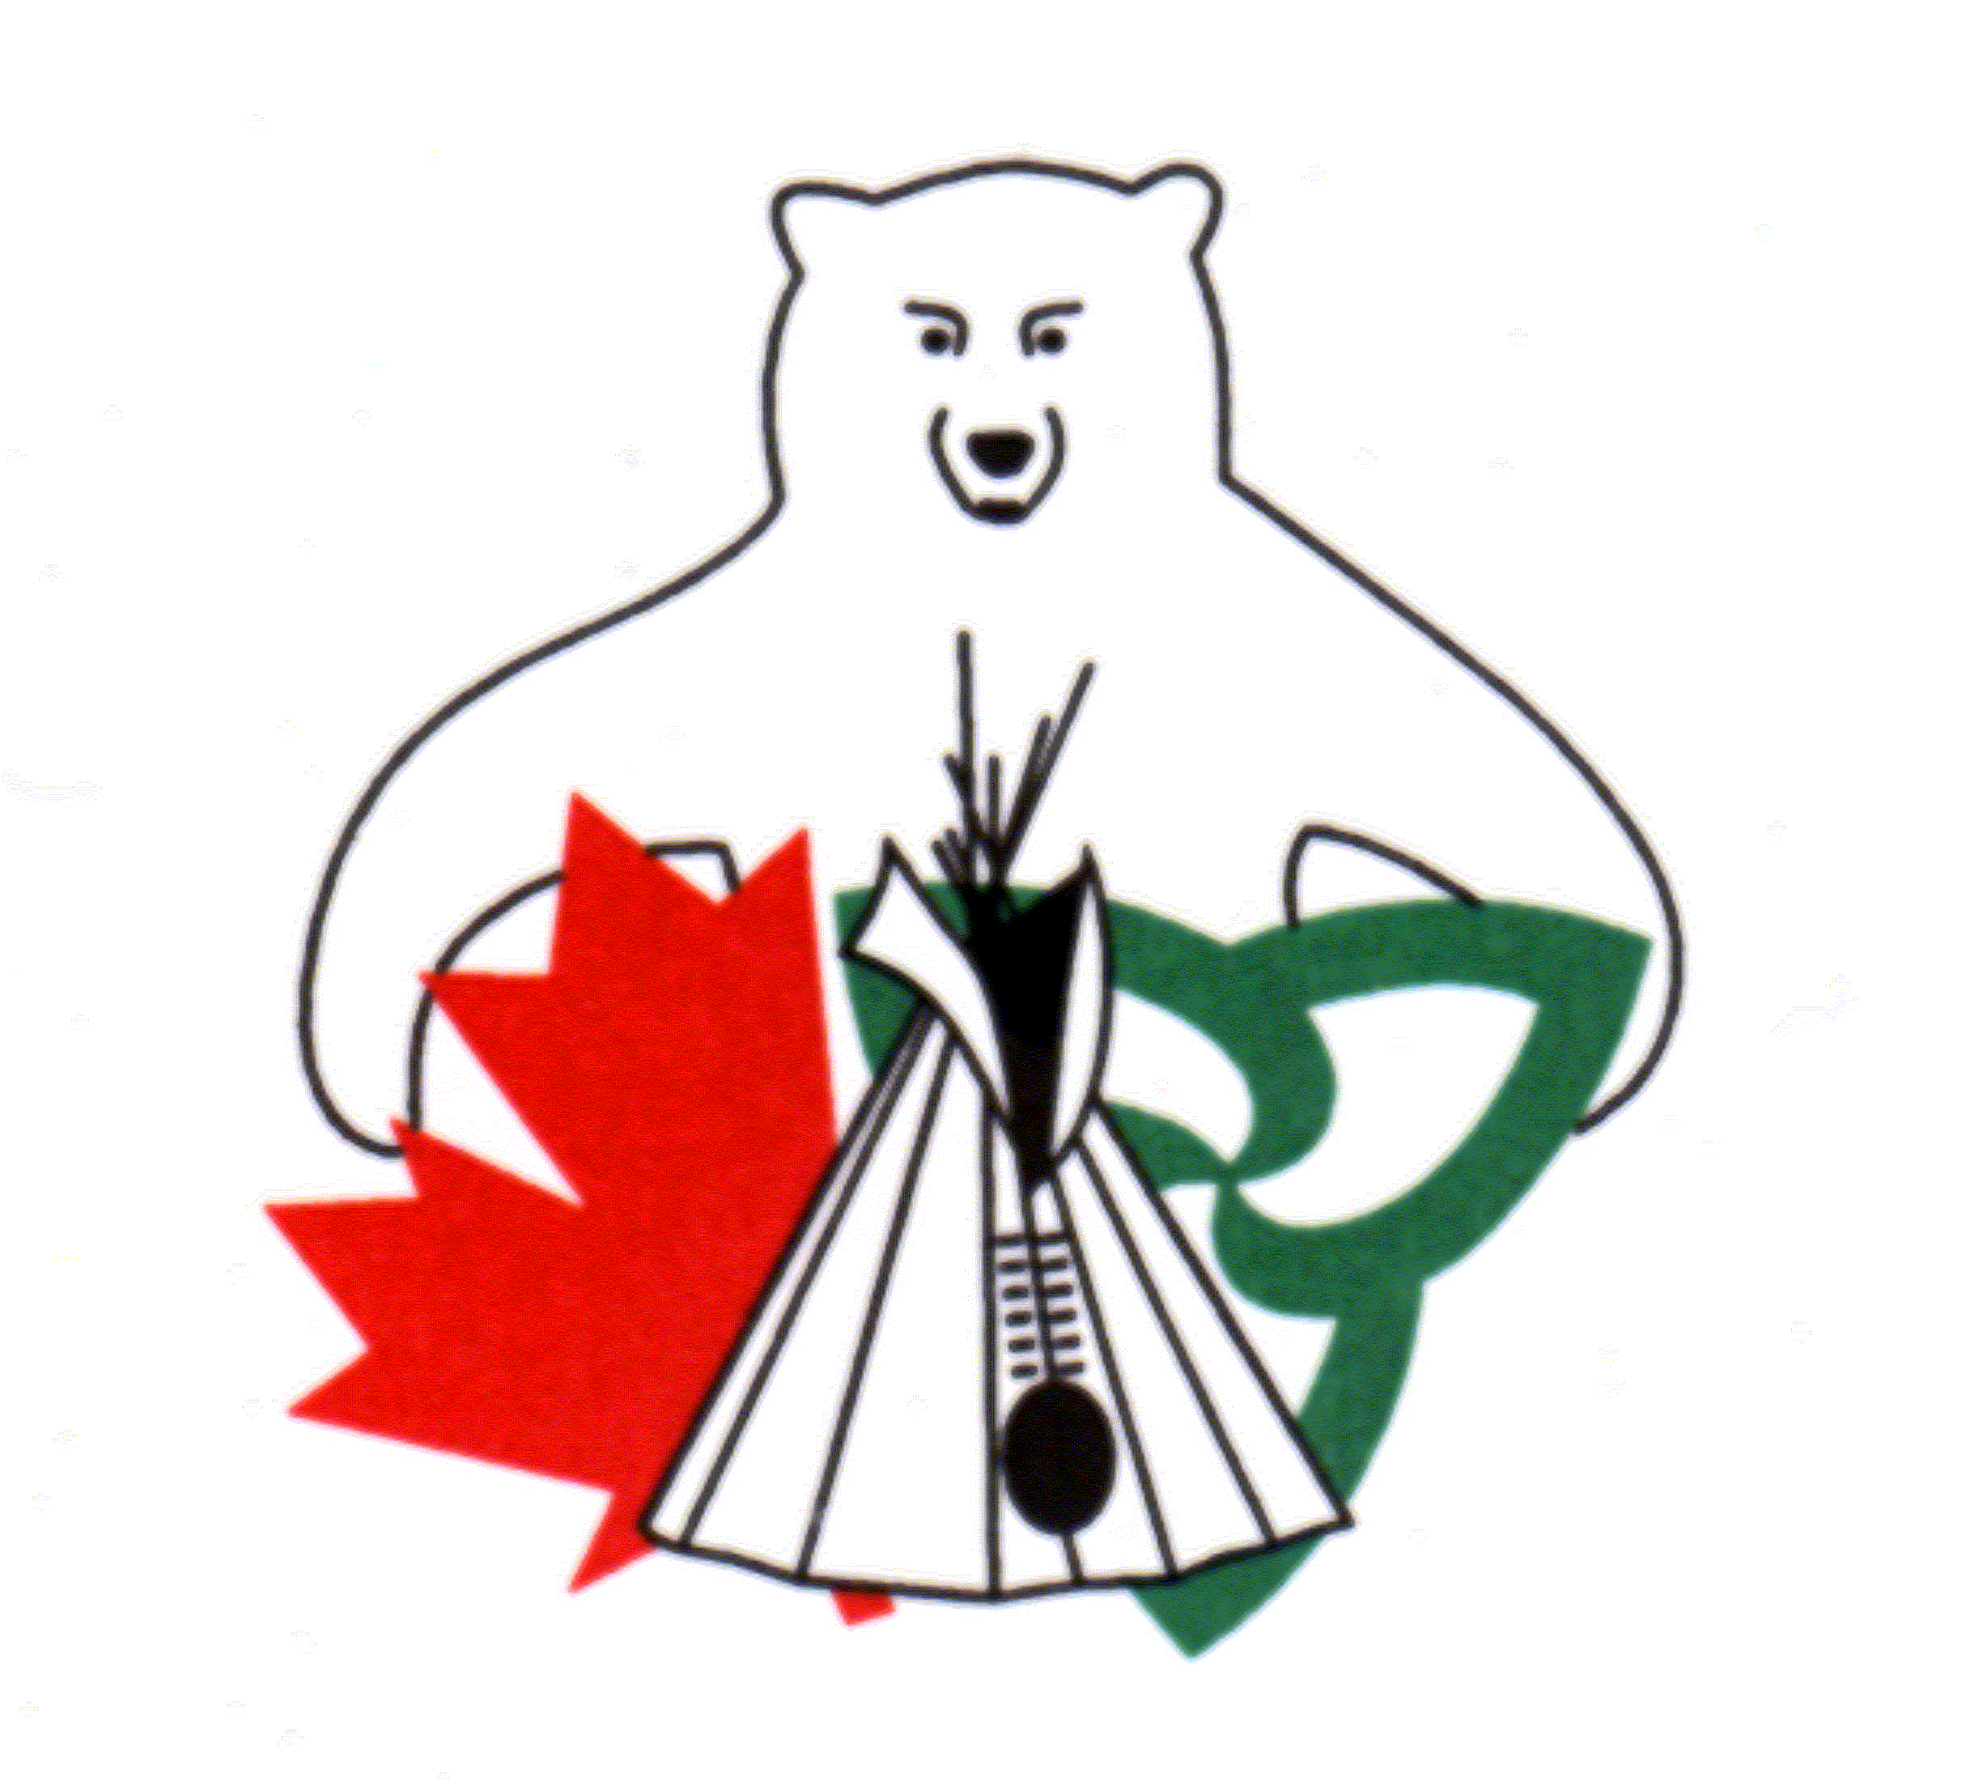

2024-2025 Application Guide Book
The CORDA Office is now accepting applications for 2024-2025 funding.

FUNDING FOR 2024-2025 AND BEYOND IS SUBJECT TO FUNDING AVAILABILITY. Proposals will be received and reviewed in anticipation of funding availability. Final approval of projects will be based on the confirmation of funding

Applications must be submitted to the CORDA Office by
Monday, November 6, 2023
at 11:59 p.m. Eastern Standard Time

Section1: Overview of the CORDA Program

The Canada Ontario Resource Development Agreement (CORDA) is an Agreement between Canada, Ontario and First Nations’ members in Ontario. The Agreement promotes resource and economic development initiatives of First Nations members by providing financial assistance to develop and utilize sustainable natural resources. CORDA receives funding from Indigenous Services Canada (ISC) and the Northern Development, Mines, Natural Resources and Forestry (MNRF).

Applicants are encouraged to review this Application Guide Book in full and to ensure they have sufficient time to obtain the necessary supporting documents in advance of the application deadline.

Who is Eligible to Apply:
For all projects, First Nations, their members or organizations, and territorial organizations in Ontario are eligible to apply. (First Nations and First Nations’ Governments have the same meaning as Indian Bands or their successors under federal legislation and any new Canadian Constitutional arrangements).

Applicants must be residents of Ontario.

Eligible Projects:
To be eligible for consideration, the application shall meet and demonstrate the following criteria:

- The project must promote natural resource development, management, harvesting or conservation in Ontario. Projects must involve one or more of the following:

- Natural resource based economic projects that build capacity, resilience and opportunities
- Traditional natural resource based projects that build capacity, culture and skills
- Natural resource based stewardship and planning projects that build capacity, sustainability and address threats

Examples are:
- Commercial Fishing, including all aspects of sustained yield production and quality control
- Fur Trapping, including all aspects of trap line management and pelt quality control
- Forestry, harvesting, maintenance, renewal and access
- Non-timber forest products including wild rice, blueberries, wild traditional crops and medicinal plants
- Deer, bear, barren-ground caribou and moose hide utilization
- Sports fishing and hunting, including assistance to guides and outfitters
- Fishing and hunting for domestic use

- Commercial recreation related to the development of renewable natural resources including ecotourism, hunting camps, guiding, skiing and snowmobile trails
- Processing and marketing of products derived from natural resource development, management and harvesting
- Environmental projects relating to renewable natural resource development and stewardship
- Natural resource planning such as those projects related to natural heritage or addressing invasive species

- Any previous projects by the applicant must be in good standing.

The maximum funding amount per approved project under the CORDA Program is
$35,000.00

Eligible Expenditures:
Expenditures eligible for funding under this program include but are not limited to:
- Equipment (e.g. purchase or rental of equipment)
- Materials (e.g. building materials or purchase of facilities)
- Labour (excludes labour for applicant)
- Transportation (e.g. transportation of personnel, supplies and equipment)
- Other (e.g. technical advice and assistance, acquisition of data base information, promotion and advertising of commercial ventures)

Ineligible Expenditures:
Expenditures under this program do not include:
- pleasure crafts and recreational vehicles
- personal or domestic expenditures
- project administration costs
- labour costs for the applicant

Section 2: Completing the Application

Part 1: Applicant Information
Provide applicant and contact information

Part 2: Project Details
Applicants must provide details outlining the resource management and economic aspects of the proposed project including:
- Background information on the objectives, project description, resources utilized, etcetera;
- Information on the project location

Applicants are responsible to demonstrate, in writing, that projects are environmentally sound and meet all applicable environmental guidelines and regulations. Some applications may be subject to a federal environmental screening process. All projects are subject to applicable Ministry of Natural Resources and Forestry permits or licensing requirements.

Part 3: Project Benefits
- Identify short- and long-term economic, resource and cultural benefits
- Identify partnerships and agencies providing financial or advisory services

Part 4: Project Costs/Budgets
Applicants must provide the proposed project costs and budget for the project. The budget information will be compared to supplier quotes submitted with the application.
Multiple applications for the same project activity (project splitting) to maximize funding are not eligible.

Part 5: Supporting Documents
Required:
All applications must include the required supporting documents. Applications that do not include the required supporting documents at the time of submission will not be reviewed. Required documents include:
- Supplier quotes for all proposed expenditures.
- A demonstration of community support by either a letter from Chief, a member of Council or a senior staff member such as the Band Administrator, or a First Nation Council Resolution (FNCR). Applications where the First Nation is the applicant must include an FNCR. Applicants may not sign their own support letter.
- Clear maps and a description of the location of the project activities. A mapping tool website is provided on the application form.

RECOMMENDED:
Applicants may also wish to provide additional documents to support the application. These documents may include, but are not limited to:
- Photographs
- Permits and/or licenses (e.g. trapping, fishing)
- Community Economic Development Plan, feasibility study, or Business Plan
- Other, as appropriate for the application

Section 3: Application Submission and Processing

Submitting an Application
Incomplete, unsigned, or late applications will not be considered. Submission of an application does not guarantee approval for funding. Applicants are encouraged to submit their application by e-mail to corda@hiawathafn.ca.

Application Deadline
The complete application package, including a complete and signed application form and all required supporting documents, must be received by the CORDA Office by Monday, November 6, 2023 at 11:59 p.m. Eastern Standard Time.

Approval Process
Complete applications received by the deadline will be screened for eligibility; eligible applications will be reviewed and ranked based on scoring criteria established by the CORDA Committee. Projects may at times be approved for a funding amount less than requested.

Where applicable, federal and provincial permits and approvals are required prior to the final approval of the project. Examples include MNRF work permits for repairs and construction to trapping cabins. Applicants will be provided with information in cases where a permit or licence is required.

Approved projects will be sent an approval letter and a Conditions of Receipt of a CORDA Grant form, along with copies of the Interim and Final Report templates to support reporting requirements. The funding recipient must return a signed copy of the Conditions of Receipt of a CORDA Grant form to the CORDA Office.

Section 4: Funding Disbursement, Reporting Requirements and Other Considerations

For approved projects, the funding disbursement schedule and reporting requirements is as follows:

Funding Disbursement Schedule
Funding disbursement | Timing
50% | After the recipient signs and returns the Conditions of Receipt of a CORDA Grant form to the CORDA Office. Funding may not be released until after July 1, 2024.
25% | Released after the CORDA Secretariat has received and reviewed the Interim Report. Interim Reports are due to the CORDA Office on or before October 11, 2024
25% | Released after the CORDA Secretariat has received and reviewed the Final Report. Final Reports are due to the CORDA Office on or before February 24, 2025.

Reporting Requirements and Timeline
- An Interim Report is due to the CORDA Office by October 11, 2024. The funding installment of 25% of approved funding will be released late October after the CORDA Secretariat has reviewed and approved the Interim Report. The Interim Report must demonstrate how the 50% installment has been spent before the next installment will be released.

- A Final Report is due to the CORDA Office no later than Friday, February 24, 2025. The final installment of 25% will be released after the CORDA Secretariat has reviewed and approved the Final Report. The Final Report must demonstrate spending for the entire project. The amount reimbursed will be based on project expenses, up to the amount approved. If the project is under-budget, the recipient will receive funding in the amount demonstrated by the Final Report.

Other Considerations:
- The timing of the release of funding varies from year to year. Funding may not be released until after July 1, 2024.
- Funding will not be provided for expenses incurred prior to April 1, 2024.
- All expenditures must be based on the approved budget.
- All project changes and budget revisions require approval from the CORDA Secretariat.
- All recipients must keep original receipts and invoices for review or audit purposes. The CORDA Office will randomly select and review receipts from 10% of projects. Recipients selected for the review will be notified they must provide clear copies of all receipts and invoices with the Final Report.
- Submission of the Final Report after the deadline or failure to submit a Final Report will result in no additional funds being released to the project.
- Any unused funds must be returned to the organization that issued those funds by Friday, March 10, 2024.

For more information, contact:

Laura Howard, Secretariat
CORDA Office
431 Hiawatha Line
Hiawatha, ON K9J 0E6
Telephone: 705-295-4421
E-mail: corda@hiawathafn.ca

