2023 Neyaashiinigmiing 37th Annual Traditional POW WOW NEYAASHIINIGMIING PWAAGNIGAA
HONOURING OUR VETERANS – Gchitwaawindagziwag Pwaagngaa
Fri., August 18th, Sat., August 19th, and Sun., August 2023

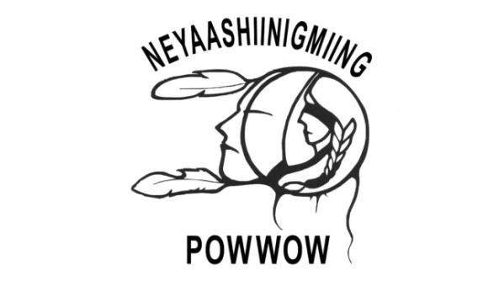
Thank you for your interest in operating a booth at this year’s POW WOW. Please complete the following VENDOR REGISTRATION APPLICATION and forward to the address given below. You are required to fully complete each section of the vendor application and read the Vendor Terms & Information section on the back.

VENDOR CONTACT INFORMATION

Booth Name: Contact:

First Nation/Organization:

Postal Address:

Phone Number: Alternate Number:

E-mail Address:

Web Page:

Support Staff Member # 1:

Support Staff Member # 2:
Support Staff Member # 3:

Support Staff Member # 4:

Support Staff Member # 5:

О Food ($400.00) О Craft ($200.00) О Information (By Donation)

50% percent of the Vendor Fee is required to secure a spot at the POWWOW.

ADDITIONAL INFORMATION

Vendor Items:

Electrical/Other Requirements:

Three wrist bands will be provided, additional ones will need to be purchased at $5.00 per.
PLEASE SUBMIT ELECTRONICALLY OR RETURN COMPLETED APPLICATION TO:

2023 Neyaashiinigmiing 37th Annual Traditional POW WOW
Community Celebration Coordinator
Chippewas of Nawash Unceded First Nation
135 Lakeshore BLVD
Neyaashiinigmiing ON N0H 2T0

Cell: (519) 379-9071 email: celebrationcoord@nawash.ca

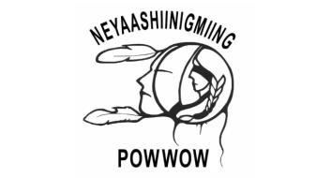
VENDOR TERMS & INFORMATION

The Chippewas of Nawash First Nation and the Cape Croker Park will provide electricity, *water and a grey water disposal area.

All work displayed MUST be the original creation of the Vendor/s. Absolutely all works of art must be hand crafted. Mass produced items, works made from kits or manufactured items will not be allowed.

All Vendors MUST provide Band Numbers and/or First Nation affiliation.

Vendors must provide their own displays, booths, chairs and tables.

BOOTH SPACE is based on a 10 x 10 booth, Food – 400.00 Craft – 200.00
Vendors are required to provide their own booth materials and equipment. In addition to the vendor registration application form, it would be appreciated if you would provide a detailed sketch setting out the dimensions and design of the booth; photographs would also be accepted. Space is limited. Once a completed vendor application has been received, changes in tent or booth size will be authorized on a case by case basis up until one week prior to the POW WOW. Tents or trailers that appear on site larger than previously approved may not be accommodated or will have a financial cost added.

Power on site is limited, so please indicate on your application what your power requirements are by indicating what equipment you propose to use. Please attach/include all expected electrical requirements on the application. Each booth will have access to one outlet and each Vendor must supply her/his own CSA approved extension cords, power bars, lights, etc. Portable generators are the responsibility of the Vendor and the exhaust must be kept away from the public.

Although Information Booths are not required to pay a fee, we do ask that a donation is given and or some gift items provided for the giveaway at the end of the POWWOW on Sunday evening.

